This defensive driver training information will guide you through the training.

*Marketing and Regulatory Programs require defensive driver training for all operators of Government Owned (or leased) Vehicles (GOV).  This training is required every three years and applies to anyone operating a GOV on government business. In order to meet this requirement we will be utilizing the free on-line training available through GSA. The course takes approximately four hours to complete and includes a test at the end. Once you pass the test, you will be able to print a certificate of completion.*

**Follow this hyperlink to** [GSA Fleet Drive-Thru](https://drivethru.gsa.gov/fmdtsys/dthome)  **and you will see the following webpage. to the site below.**

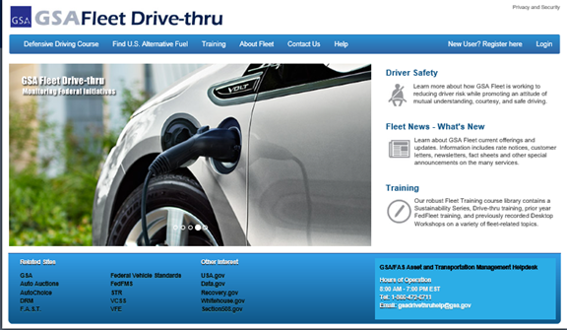

**SELECT: “ DEFENSIVE DRIVING COURSE “ – (ENTER an assigned vehicle license plate number and government email address)**[**xxxxxxxxxxxxxxx@usda.gov**](mailto:xxxxxxxxxxxxxxx@usda.gov) **)**

* If a vehicle isn’t permanently assigned, check with your Local Fleet Coordinator to obtain a leased vehicle license plate number. If you have all owned vehicles, contact your RFPC for vehicle license plate number.
* Turn off Pop-up blocker

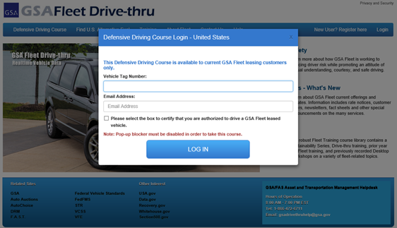

FROM THIS POINT – SELECT: “ Register for the Defensive Driving Course ”

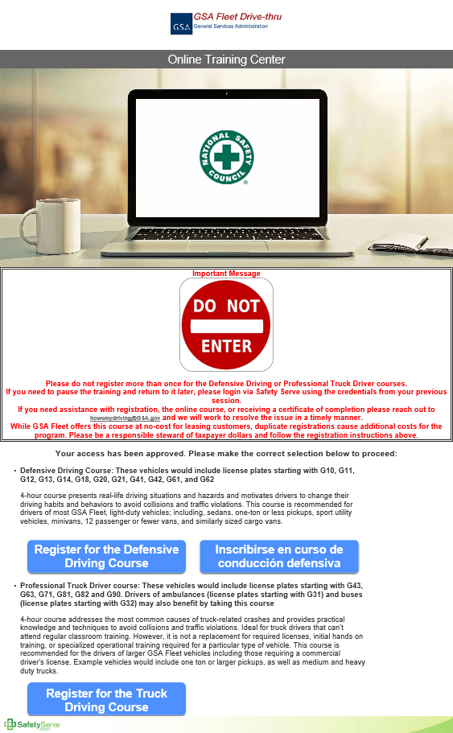

FROM THIS POINT - Complete all required fields on the registration and submit. *(create your own Login ID & password)*

* Remember to save all work when exiting the training course and return later to resume. *(you will receive an email with instructions for returning, to resume. The email will have the URL Address and your Login ID)*

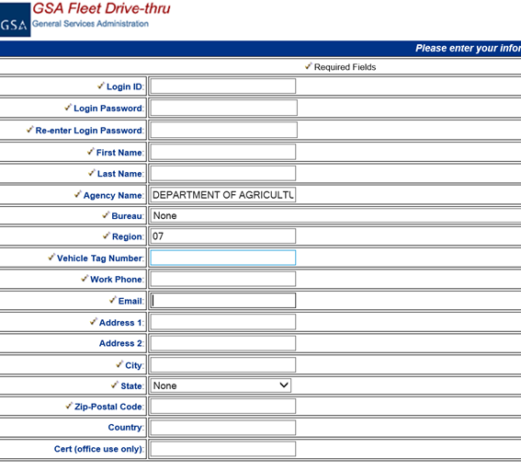

WHEN FINISHED – Print certificate for your record (***If the certificate will not print, make sure the pop-up blocker is disabled)***