Stakeholder Toolkit
  - Local Agriculture Market Program Grants
The Local Agriculture Market Program (LAMP) Stakeholder Toolkit includes resources to help organizations amplify funding available through the Fiscal Year (FY) 2024 LAMP grants. LAMP encompasses the Farmers Market Promotion Program (FMPP), Local Food Promotion Program (LFPP), Regional Food System Partnerships Program (RFSP), and Value-Added Producer Grants Program (VAPG). The USDA Agricultural Marketing Service (AMS) administers FMPP, LFPP, and RFSP. VAPG is administered through USDA Rural Development (RD). The Stakeholder Toolkit focuses only on funding available through USDA AMS for FMPP, LFPP, and RFSP. All information provided is available for public use.
Toolkit includes:
Program Information
- Introduction & Overview
- Key Dates and Request for Applications (RFAs)
- Eligible Applicants
- Project Types
- Timing to Obtain and Submit Grants.gov Required Elements
- Webinars
- Additional Information
- Key Messages: Local Agriculture Market Program (LAMP)
Shareable Resources
- Individual Graphics
- Sample Social Media Resources
- Sample Social Media Posts w/Graphics
- Sample Emails to Stakeholders
- Program Quick Links
Thank you for your help in spreading the word about these important funding opportunities!

Program Information

Introduction & Overview
AMS announced approximately $24.7 million in grant funding available through the Local Agriculture Market Program (LAMP) grants. This funding will help local and regional food entities develop, coordinate, and expand producer-to-consumer marketing, local and regional food markets, and local food enterprises for Fiscal Year 2024.
The funding will be distributed through LAMP’s Local Food Promotion Program (LFPP), Farmers Market Promotion Program (FMPP), and the Regional Food System Partnerships (RFSP) grant program. LAMP is authorized by the 2018 Farm Bill.
LAMP programs support the development, coordination, and expansion of direct producer-to-consumer marketing, local and regional food markets and enterprises, and value-added agricultural products. LAMP’s primary goals are to:
- Connect and cultivate regional food economies through public-private partnerships;
- Support the development of business plans, feasibility studies, and strategies for value-added agricultural production and local and regional food system infrastructure;
- Strengthen capacity and regional food system development through community collaboration and creating new market opportunities for value-added and niche products; and
- Improve income and economic opportunities for producers and food businesses through job creation.

Program Name | Approximate Funding Amount
Farmers Market Promotion Program | $10.2M
Local Food Promotion Program | $10.2M
Regional Food System Partnerships | $4.3M

Key Dates and Request for Applications (RFAs)
Funding Opportunity Name | Opportunity Number | Open Date | Closing Date
Farmers Market Promotion Program | USDA-AMS-TM-FMPP-G-24-0010 | 2/27/2024 | 5/14/2024
Local Food Promotion Program | USDA-AMS-TM-LFPP-G-24-0011 | 2/27/2024 | 5/14/2024
Regional Food System Partnerships | USDA-AMS-TM-RFSP-G-24-0007 | 2/27/2024 | 5/14/2024

Eligible Applicants
Program | Eligible Entity
Farmers Market Promotion Program and Local Food Promotion Program | All applicants must be domestic entities owned, operated, and located within the 50 United States, the District of Columbia, the Commonwealth of Puerto Rico, the United States Virgin Islands, Guam, American Samoa, and the Commonwealth of the Northern Mariana Islands, or Tribal Governments.  Eligible Entities includes:  - Agricultural Businesses and Cooperatives  - Producer Networks and Associations  - Community Supported Agriculture (CSA) Networks and Associations  - Food Councils  - Local Governments  - Nonprofit and Public Benefit Corporations  - Economic Development Corporations  - Regional Farmers Market Authorities  - Tribal Governments
Regional Food System Partnerships | Partnerships are eligible to apply to RFSP. A partnership is an agreement between one or more eligible entities and one or more eligible partners. The agreement may be in the form of any official documentation, such as a contract or Memorandum of Understanding (MOU).  An application may be submitted either by an eligible entity or an eligible partner on behalf of the partnership. The partnership must specify in its application which organization(s) in the partnership are responsible for receiving and managing the award.  Partnerships that include Limited Resource Entities, an organization that provides technical assistance services to and engages historically underserved farmers and ranchers in addressing their needs, are strongly encouraged to apply.  All applicants must be domestic entities owned, operated, and located within the 50 United States, the District of Columbia, the Commonwealth of Puerto Rico, the United States Virgin Islands, Guam, American Samoa, and the Commonwealth of the Northern Mariana Islands, or Tribal Governments.  Eligible Entities includes:  - Producers  - Farmer and Rancher Cooperatives  - Producer Networks and Associations  - Food Councils  - Majority-Controlled Producer-Based Business Ventures  - Community Supported Agriculture (CSA) Networks and Associations  - Local Governments  - Nonprofit and Public Benefit Corporations  - Public Benefit Corporations  - Economic Development Corporations  - Regional Farmers Market Authorities  - Tribal Governments  Eligible Partners include:  - State Agencies or Regional Authorities  - Philanthropic Corporations  - Private Corporations  - Institutions of Higher Education  - Commercial, Federal or Farm Credit System Lending Institutions

Project Types
Farmers Market Promotion Program
Project Type | Duration (Months) | Start Date | Completion Date | Minimum Award | Maximum Award
Capacity Building | 36 | September 30, 2024 | September 29, 2027 | $50,000 | $250,000
Community Development Training and Technical Assistance | 36 | September 30, 2024 | September 29, 2027 | $100,000 | $500,000
Turnkey Marketing and Promotion | 24 | September 30, 2024 | September 29, 2026 | $50,000 | $100,000
Turnkey Recruitment and Training | 24 | September 30, 2024 | September 29, 2026 | $50,000 | $100,000
Local Food Promotion Program
Project Type | Duration (Months) | Start Date | Completion Date | Minimum Award | Maximum Award
Planning | 24 | September 30, 2024 | September 29, 2026 | $25,000 | $100,000
Implementation | 36 | September 30, 2024 | September 29, 2027 | $100,000 | $500,000
Turnkey Marketing and Promotion | 24 | September 30, 2024 | September 29, 2026 | $50,000 | $100,000
Turnkey Recruitment and Training | 24 | September 30, 2024 | September 29, 2026 | $50,000 | $100,000
Regional Food Systems Partnerships
Project Type | Duration (Months) | Start Date | Completion Date | Minimum Award | Maximum Award
Planning & Design | 24 | September 30, 2024 | September 29, 2026 | $100,000 | $250,000
Implementation & Expansion | 36 | September 30, 2023 | September 29, 2027 | $250,000 | $1,000,000

Marketing and Promotion Turnkey Project Type
The Turnkey Marketing and Promotion option offers a simplified application for common FMPP and LFPP marketing and promotion activities. Those applying to the Turnkey Marketing and Promotion can choose from specific activities that support intermediated producer-to-consumer market opportunities for local and regional foods. Applicants must select 3-5 pre-defined activities listed below:
• Identify and analyze new or improved market opportunities.
• Develop or revise a marketing plan.
• Design or purchase marketing and promotion media.
• Implement a marketing plan.
• Evaluate marketing and promotion activities.

Recruitment and Training Turnkey Project Type
Turnkey Recruitment and Training projects are intended to offer a simplified application for some of the most common FMPP and LFPP grant activities related to development or delivery of vendor and producer recruitment strategies, as well as training opportunities, for local and regional food system stakeholders. Turnkey applications must clearly demonstrate benefits to farmers and ranchers. Applicants applying to the Turnkey Recruitment and Training track must choose 3-5 pre-defined activities listed below:
• Identify and analyze new or improved vendor/producer recruitment and/or training opportunities.
• Develop or revise vendor/producer recruitment and/or training plan.
• Design vendor/producer recruitment and/or training materials.
• Implement vendor/producer recruitment and/or training plan.
• Evaluate vendor/producer recruitment and/or training and related outcomes.

Timing to Obtain and Submit Grants.Gov Required Elements
Required Action | Timing to Obtain/Submit
AMS Deadline to receive final application and all supporting materials through Grants.Gov | May 14, 2024 – 11:59 p.m. Eastern Time
Obtaining Your Organization’s UEI Number (if you do not already have one) | 7-10 business days
Establishing an Active SAM.gov Account (if you do not already have one) | 7-10 business days
Obtaining a TIN/EIN (if you do not already have one) | Up to 2 weeks
Creating your Grants.gov profile and registering your Authorized Organizational Representative (AOR) authorization | Up to 2 weeks

Webinars
Farmers Market Promotion Program (FMPP) Applicant Webinar
When: March 26, 2024, 1:00 PM – 3:00PM Eastern Time (US and Canada)
Topic: U.S. Department of Agriculture (USDA), Agricultural Marketing Service (AMS) announced approximately $10.2 million in competitive grant funding for the Farmers Market Promotion Program and the Local Food Promotion Program. Funding helps to expand direct producer-to-consumer markets and local and regional food business enterprises. Find more information at: https://www.ams.usda.gov/services/grants/webinars.
Local Food Promotion Program (LFPP) Applicant Webinar
When: March 27, 2024, 1:00 PM – 3:00PM Eastern Time (US and Canada
Topic: U.S. Department of Agriculture (USDA), Agricultural Marketing Service (AMS) announced approximately $10.2 million in competitive grant funding for the Farmers Market Promotion Program and the Local Food Promotion Program. Funding helps to expand direct producer-to-consumer markets and local and regional food business enterprises. Find more information at: https://www.ams.usda.gov/services/grants/webinars.
Regional Food System Partnerships (RFSP) Applicant Webinar
When: March 27, 2024, at 1:00 PM – 3:00PM Eastern Time (US and Canada)
Topic: U.S. Department of Agriculture (USDA), Agricultural Marketing Service (AMS) announced approximately $4.3 million in competitive grant funding for the Regional Food System Partnerships Program (RFSP). Funding helps organizations explore new market opportunities for U.S. food and agricultural products and encourages resilience and development of local or regional food systems. Find more information at: https://www.ams.usda.gov/services/grants/webinars.

Additional Information
For more information about grant eligibility and previously funded projects, visit the below webpages or use the contact information.
Funding Opportunity | Webpage | Support Email
FMPP | www.ams.usda.gov/fmpp | FMLFPPgrants@usda.gov
LFPP | www.ams.usda.gov/lfpp | FMLFPPgrants@usda.gov
RSFP | www.ams.usda.gov/rfsp | IPPGrants@usda.gov

Do you need grant writing tips?
Check out the Grants.Gov website. This series of tips will help you prepare a solid grant application package: https://grantsgovprod.wordpress.com/category/learngrants/grant-writing-basics/.

Key Messages

Local Agriculture Market Program (LAMP)
- USDA is investing nearly $25 million in grants through the Local Agriculture Market Program (LAMP) that develop, coordinate, and expand producer-to-consumer marketing, local and regional food markets, and local food enterprises. LAMP was authorized in the Agriculture Improvement Act of 2018 (Farm Bill).
- USDA’s LAMP is made up of the Farmers Market Promotion Program (FMPP), Local Food Promotion Program (LFPP), Regional Food System Partnerships Program (RFSP), and Value-Added Producer Grants Program (VAPG). The USDA Agricultural Marketing Service (AMS) administers FMPP, LFPP, and RFSP. VAPG is administered through USDA Rural Development (RD), and therefore is not included in this stakeholder toolkit.
- AMS encourages applications that support smaller farms and ranches, new and beginning farmers and ranchers, historically underserved producers, veteran producers, and underserved communities.
- USDA recognizes that resilient and adaptable local and regional food systems are essential for the future of the food system. Which is why, USDA continues to support the creation of more and better markets through LAMP.
- AMS will host application webinars and work with stakeholder organizations to help different groups navigate the application process and understand best practices for greatest chance of success.
- AMS is launching the LAMP Navigator, a tool that enable users to explore funding data, metrics, project details, and other award information from LAMP projects.

Farmers Market Promotion Program and Local Food Promotion Program
- The Farmers Market Promotion Program (FMPP) and Local Food Promotion Program (LFPP) support farmers by creating targeted marketing capabilities, training on record keeping, pricing, family-friendly marketing and agri-tourism activities, and strategies to retain vendors and consumers. This year, approximately $20.4 million is available to fund projects through FMPP and LFPP.
- FMPP focuses on direct-to-consumer markets and LFPP focuses on indirect to consumer markets.
- Since 2006, FMPP and LFPP have invested $405 million across all 50 states and territories for 2,250 projects.
- The FY24 RFAs offer two simplified applications for smaller grants: the Turnkey Recruitment and Training option, as well as the Turnkey Marketing and Promotion option. These applications reduce the paperwork requirements for applicants requesting smaller awards for some of the most common FMPP and LFPP grant activities.
  - Applicants applying to the Turnkey Recruitment and Training option agree to conduct specific activities that support the development or delivery of vendor and producer recruitment strategies, as well as training opportunities. Those activities are pre-defined in the application form and may not be modified.
  - Applicants applying to the Turnkey Marketing and Promotion option agree to conduct specific activities that support the marketing and promotion of intermediated producer-to-consumer market opportunities for local and regional foods. Those activities are pre-defined in the application form and may not be modified.
  - All Turnkey applicants will use a simplified “Turnkey Project Narrative Forms”.
- Eligible entities include agricultural businesses and cooperatives, Community Supported Agriculture (CSA) networks and associations, food councils, economic development corporations, local governments, nonprofit and public benefit corporations, producer networks or associations, regional farmers’ market authorities, and Tribal governments.
- Grant recipients must provide a 25% cash or in-kind match of the federal portion of the grant.

Regional Food Systems Partnerships
- The Regional Food System Partnerships (RFSP) funds partnerships that connect public and private resources to plan and develop local and regional food systems. This year, $4.3 million in funding is available to support projects through RFSP.
- Since 2020, RFSP has invested $46.7 million across 41 states and the District of Columbia for 98 projects.
- Eligible applicants are partnerships that consist of at least one eligible entity and at least one eligible partner as detailed in the Request for Applications.
- Grant recipients of RFSP are required to provide a 25% cash match of the federal portion of the grant.

Shareable Resources

Individual Graphics
Image | Content
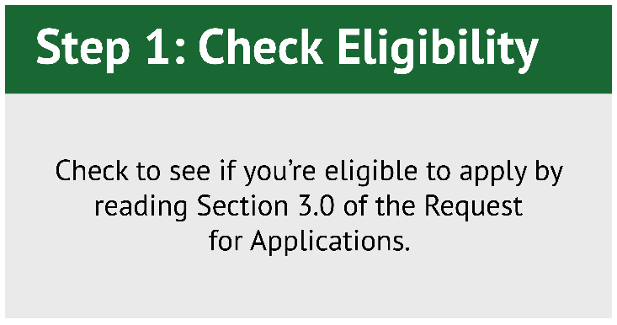 | Step 1: Eligibility  Check to see if you’re eligible to apply by reading Section 3.0 of the Request for Applications.
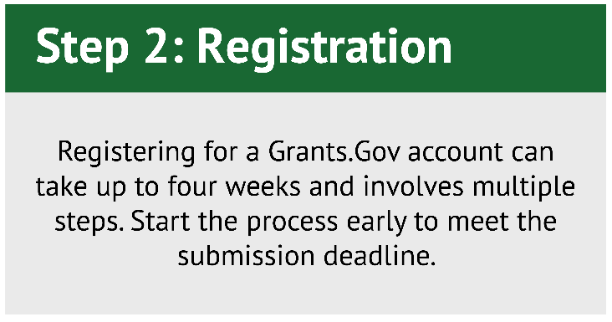 | Step 2: Register in Grants.Gov  Registering for a Grants.Gov account can take up to four weeks and involves multiple steps. Start the process early to meet the submission deadline.
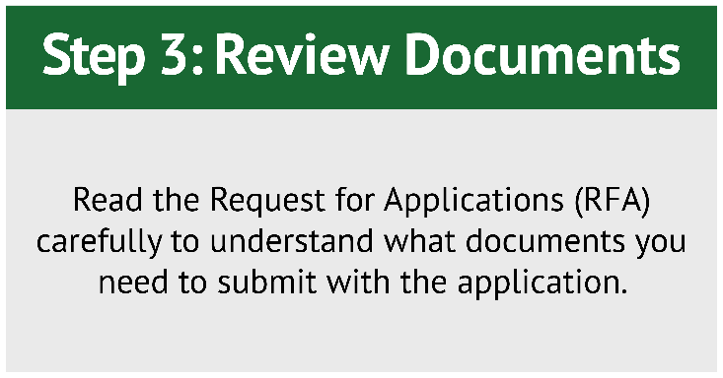 | Step 3: RFA Review  Read the Request for Applications (RFA) carefully to understand what documents you need to submit with the application.
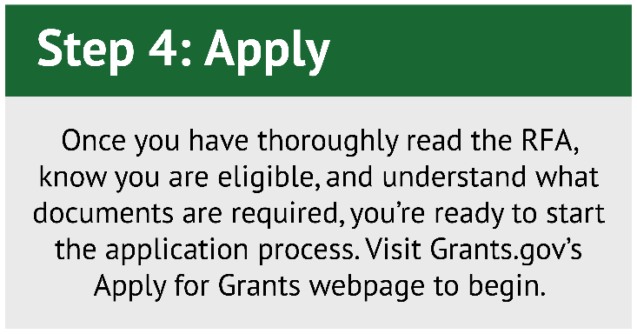 | Step 4: Apply  Once you have thoroughly read the RFA, know you are eligible, and understand what documents are required, you’re ready to start the application process. Visit Grants.gov’s How to Apply for Grants webpage to begin.

Sample Social Media Resources

Social Media

Tweets:
- Local Agriculture Market Program grants are open for applications! $24.7 million in funding available is available for the Farmers Market Promotion Program, Local Food Promotion Program, and Regional Food System Partnerships Program grants.
- Did someone say simplify? The Farmers Market Promotion Program and the Local Food Promotion Program now have TWO “turnkey” project types! Applicants proposing the most common grant activities can apply using a shorter, streamlined application.
- The FY24 Farmers Market and Local Food Promotion Programs have a new simplified project type. In addition to the Turnkey Marketing and Promotion project, USDA has created Turnkey Recruitment and Training projects. Now, that’s something to celebrate!
- USDA just announced that $24.7 is available for LAMP grants! These grants support more and better markets. Projects increase the resilience of local and regional food systems and create new opportunities small and mid-sized businesses.
- @USDA_AMS has launched a new LAMP Navigator. This interactive dashboard lets you explore funding data, metrics, project details, and other award information from three Local Agriculture Market Program projects.

Suggested Twitter Cards:
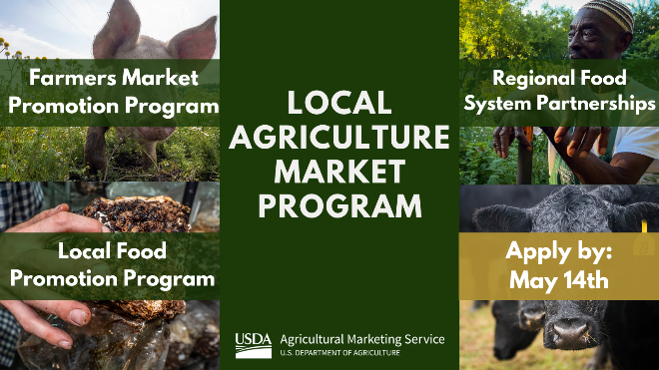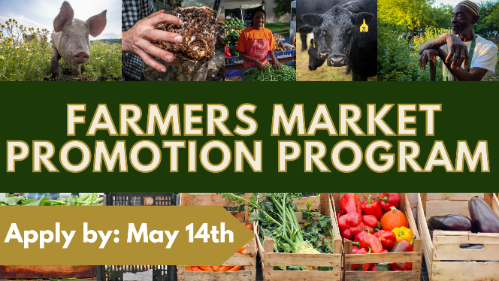
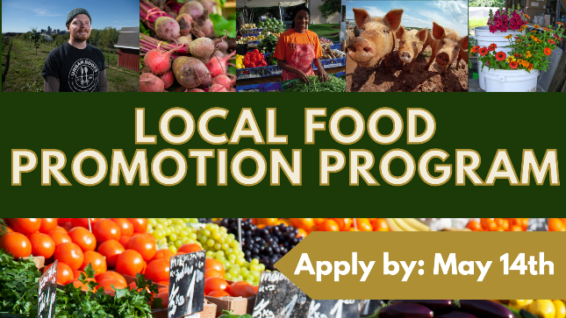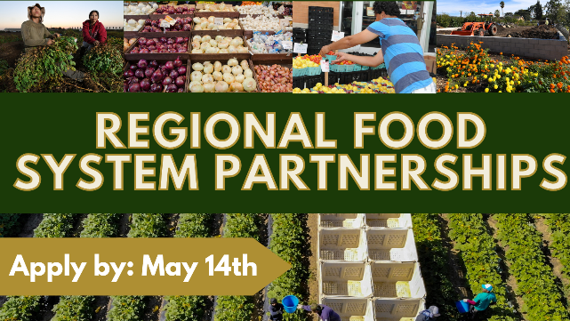

Suggested LinkedIn:
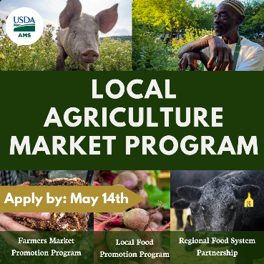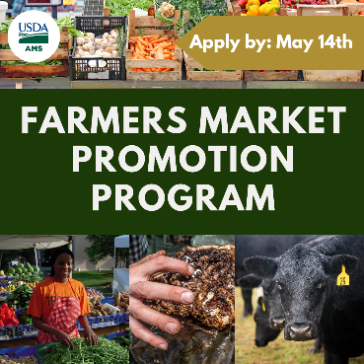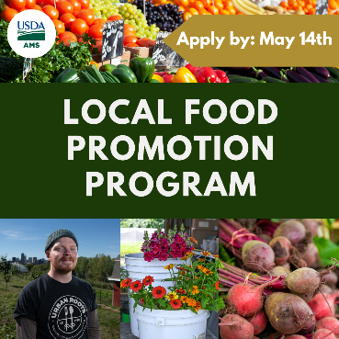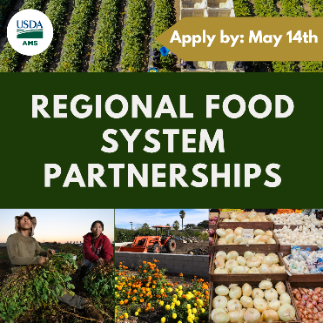

Suggested Instagram:
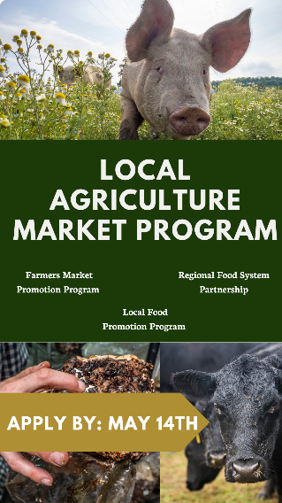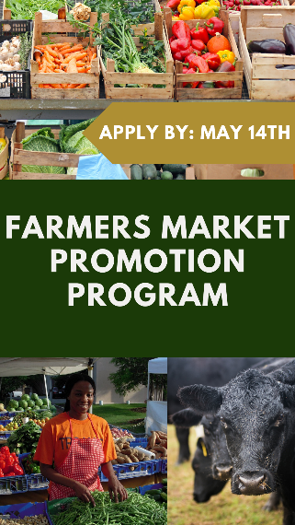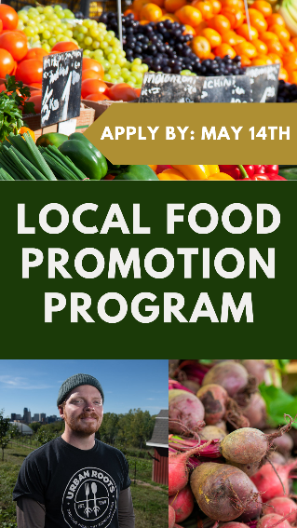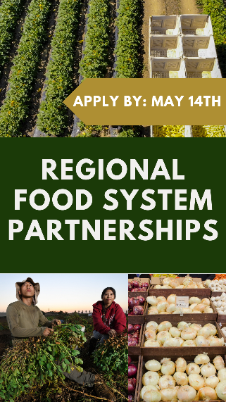
Social Media Links to Share: LinkedIn Facebook Twitter

Sample Social Media Posts w/Graphics

LAMP Grant Applications Open.
In Fiscal Year (FY) 24, approximately $24.7 million in funding is available for the Local Agriculture Market Program (LAMP), which includes the Farmers Market Promotion Program (FMPP) and Local Food Promotion Program (LFPP), and Regional Food System Partnerships (RFSP) Program.
AMS encourages applications that serve smaller farms and ranches, new and beginning farmers and ranchers, underserved producers, veteran producers, and/or underserved communities to apply.
www.grants.gov
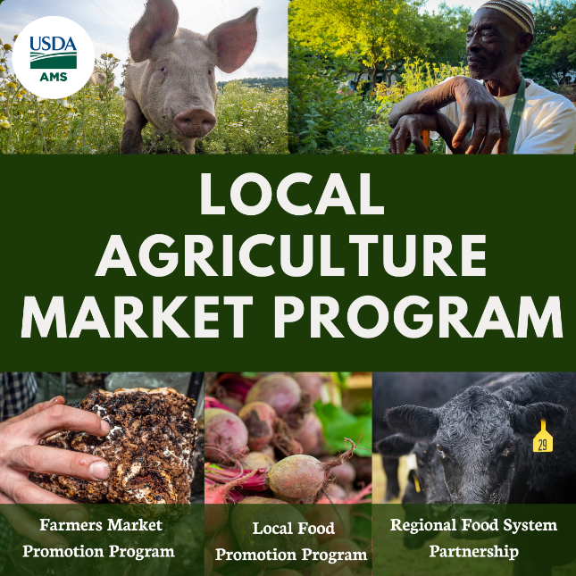

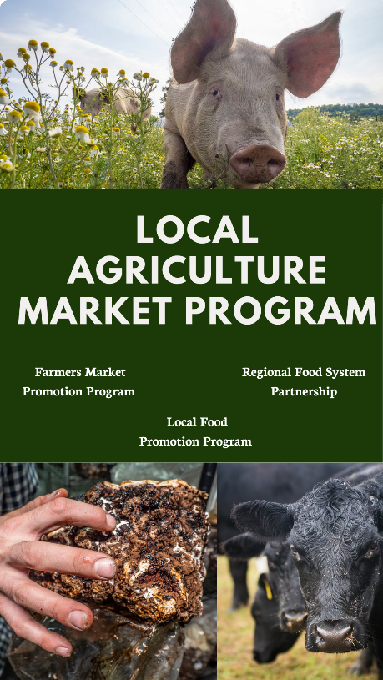
New Simplified Farmers Market and Local Food Promotion Programs Grant Opportunities!
Did someone say simplify? The FY24 Farmers Market Promotion Program (FMPP) and Local Food Promotion Program (LFPP) now have two "turnkey” project types: Turnkey Marketing and Promotion, launched last year, and a new Recruitment and Training project option. These pre-defined projects offer funding for the most common activities within each program. Smaller awards are available using shorter, streamlined applications. This year, approximately $20.2 million is available to fund FMPP and LFPP projects. Check out the applications today!
www.grants.gov

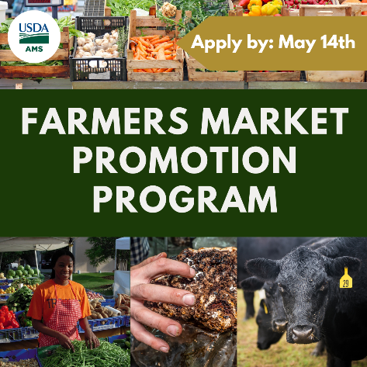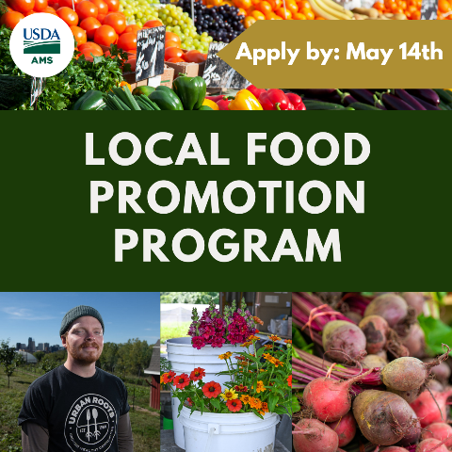

Sample Emails to Stakeholders

Long Version - Announcement to Remind Stakeholders to Share Information
Subject Line: $24.7 million in competitive USDA grant funding available in Fiscal Year (FY) 2024 to support local and regional food systems.
Body:
Great news for local and regional food systems! The USDA recently announced $24.7 million in competitive grant funding.
The Local Agriculture Market Program (LAMP) will help local and regional food entities develop, coordinate, and expand producer-to-consumer marketing, local and regional food markets, and local food enterprises. Three LAMP programs are accepting applications: Farmers Market Promotion Program (FMPP), Local Food Promotion Program (LFPP), and Regional Foods System Partnerships (RFSP).
FY 24 FMPP, LFPP, RFSP Funding
Program Name | Funding Amount
Farmers Market Promotion Program | $10.2M
Local Food Promotion Program | $10.2
Regional Food System Partnerships | $4.3
Additionally, FY24 FMPP and LFPP have a new opportunity: Turnkey Recruitment and Training projects. These simplified applications offer shorter, streamlined forms for smaller projects proposing common FMPP and LFPP grant activities.
Wondering if you qualify for funding? Want to know whether you can use the streamlined application? Read the Request for Applications (RFA). It explains who can apply for funding and how to do it. You can apply to any of the three programs now through May 14, 2024.

You can find the LAMP Requests for Applications (RFAs) on each program’s respective web page at:
FMPP: https://www.ams.usda.gov/services/grants/fmpp
LFPP: https://www.ams.usda.gov/services/grants/lfpp
RFSP: https://www.ams.usda.gov/services/grants/rfsp
USDA strongly encourages projects that support smaller farms and ranches, new and beginning farmers and ranchers, socially disadvantaged producers, veteran producers, and underserved communities.
Want More Information?
Sign up for an USDA grant webinar at https://www.ams.usda.gov/services/grants/webinars. The USDA will host a FMPP on March 26, 2024, 1:00 PM – 3:00PM ET, LFPP grant webinar on March 27, 2024, 1:00 PM – 3:00PM ET (US and Canada) and RFSP webinar on March 27, 2024, at 1:00 PM – 3:00PM ET.
Need Grant Writing Tips?
Check out the Grants.Gov website. These tips will help you prepare a solid grant application: https://grantsgovprod.wordpress.com/category/learngrants/grant-writing-basics/.
Have Questions?
USDA staff is available to help! Click on the program websites for contact information.
Not Applying, but Want to Help?
Sign up to be a peer reviewer! Reviewers help USDA choose high-quality grant applications. To learn more, visit https://www.ams.usda.gov/services/grants/peer-review.

Short Version - Announcement to Remind Stakeholders to Share Information
Subject Line: USDA Makes $24.7 Million available in Fiscal Year (FY) 2024 to support local and regional food systems
Body:
Great news for local and regional food systems! The USDA is accepting applications for $24.7 million in competitive grant funding. The Local Agriculture Market Program (LAMP) will help local and regional food entities develop, coordinate, and expand producer-to-consumer markets, local and regional food markets, and local food enterprises. Three LAMP programs are accepting applications:

- Farmers Market Promotion Program (FMPP),
- Local Food Promotion Program (LFPP), and
- Regional Foods System Partnerships (RFSP).
For Fiscal Year (FY) 24, FMPP and LFPP have a new opportunity: Turnkey Recruitment and Training projects. These simplified applications offer shorter, streamlined forms for smaller projects proposing common FMPP and LFPP activities.
Wondering if you qualify for funding?
Read the Request for Applications (RFA) at:
FMPP: https://www.ams.usda.gov/services/grants/fmpp
LFPP: https://www.ams.usda.gov/services/grants/lfpp
RFSP: https://www.ams.usda.gov/services/grants/rfsp
When is the deadline?
Applications are due May 14, 2024.
Want more information?
Sign up for an USDA grant webinar at https://www.ams.usda.gov/services/grants/webinars. The USDA will host a FMPP on March 26, 2024, 1:00 PM – 3:00PM ET, LFPP grant webinar on March 27, 2024, 1:00 PM – 3:00PM ET (US and Canada) and RFSP webinar on March 27, 2024, at 1:00 PM – 3:00PM ET.
Not Applying, but Want to Help?
Be a peer reviewer! Reviewers help USDA select high-quality grant applications. To learn more, visit https://www.ams.usda.gov/services/grants/peer-review.

Program Quick Links

Farmers Market and Local Food Promotion Program (FMLFPP)
- Fact Sheet - Farmers Market Promotion Program (FMPP)
- Fact Sheet - Local Food Promotion Program (LFPP)
- FMPP and LFPP- Frequently Asked Questions (FAQs)
- Grant Webinar Information
- Seeds of Success – USDA’s Seeds of Success series highlights the accomplishments and lessons learned from Farmers Market and Local Food Promotion Programs grant recipients.

Regional Foods System Partnerships (RFSP)
- Fact Sheet - Regional Foods System Partnerships (RFSP)
- RFSP - Frequently Asked Questions (FAQs)
- Grant Webinar Information

General
- Apply to be a Grant Reviewer
- Subscribe to our newsletter “From the Ground Up” for updates.

To create your Grants.gov account, click on the following link and scroll down to “How to Register a Grants.gov Account”: https://www.grants.gov/web/grants/applicants/registration.html
Taxpayer Identification Number (TIN) and Employer Identification Number (EIN) are defined as a nine-digit number that the IRS assigns to organizations. To obtain a free EIN from the IRS, visit: https://www.irs.gov/businesses/small-businesses-self-employed/how-to-apply-for-an-ein

